LAB 10
(Total Marks 15)

Task 1: Write a program that print asterisk on first half screen using following instructions:
- Use STOS Instruction
- Set direction flag 1
- Also Use stack and subroutine concepts
[org 0x0100]
jmp start

clrscr:
push es
push ax
push cx
push di
mov ax, 0xb800
mov es, ax ;
xor di, di ;
mov ax, 0x0720
mov cx, 2000
cld
rep stosw
pop di
pop cx
pop ax
pop es
ret

print:
push es
push ax
push cx
push di
mov ax, 0xb800
mov es, ax
mov di , 1998
mov ax, 0x072A
mov cx, 1000
std
rep stosw
pop di
pop cx
pop ax
pop es
ret
start:
call clrscr ; call clrscr subroutine
call print
mov ax, 0x4c00 ; terminate program
int 0x21
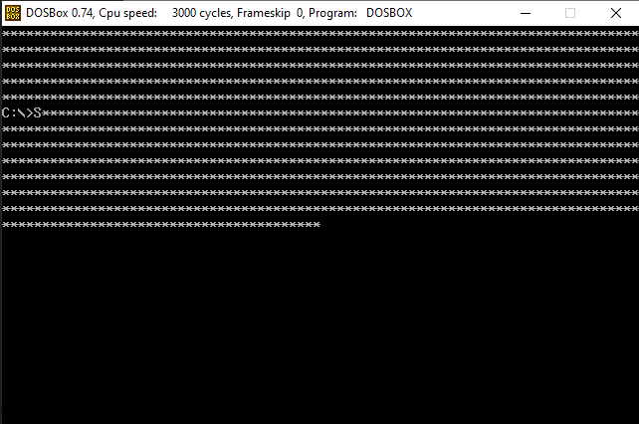
Task 2: Write a program that print the given input string (your full name) in reverse order on the screen with following instructions:
- Using STOS and LODS instruction
- You should clear the screen first and then proceed to print it
- For example: Message: db 'hello world'
- Output of above string is ‘dlrow olleh’
org 0x0100
jmp start
message: db 'Rafay Adeel'
length: dw 11
clear_screen:
push es
push ax
push cx
push di
mov ax, 0xb800
mov es, ax
xor di, di
mov ax, 0x0720
mov cx, 2000
cld
rep stosw
pop di
pop cx
pop ax
pop es
ret

printscr:
push bp
mov bp, sp
push es
push ax
push cx
push si
push di
mov ax, 0xb800
mov es, ax
mov al, 80 ; calculate position at which we need to print
mul byte [bp+10]
add ax, [bp+12]
shl ax, 1
mov di,ax ; move location to di to print on video memory
mov si, [bp+6] ; move string start locaton to si
add si, [bp+4] ; add length to si . so we cn rech to last of string
dec si
mov cx, [bp+4]
mov ah, [bp+8] ; attribute of string
print_reverse:
std ; reading it in reverse
lodsb
cld ; dispaying in straight
stosw
loop print_reverse
pop di
pop si
pop cx
pop ax
pop es
pop bp
ret 10

start:
call clear_screen
mov ax, 27 ; column number
push ax
mov ax, 21 ; row number
push ax
mov ax, 05 ; attribute of output
push ax
mov ax, message ; message
push ax
push word [length] ; length of message
call printscr
mov ax, 0x4c00
int 0x21
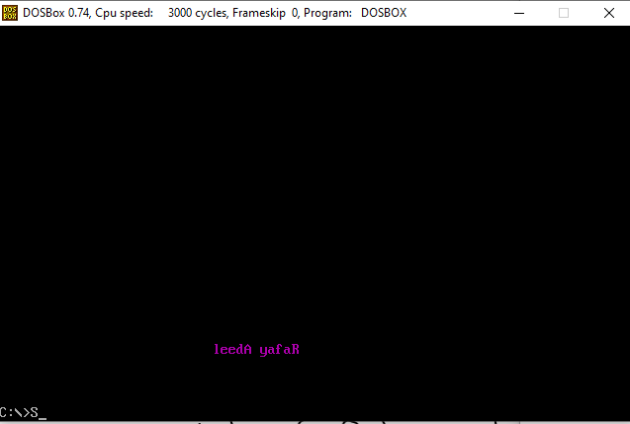
Task3: Write a program that count the number of non-vowels letter in a given string (your full name) and print its vowels letter on the screen
- Using Stos and Lods instruction
- You should clear the screen first and then proceed to print it
- Store the counter in variable
- Like Message: db 'Assembly Language'
- Output of above string is ‘ssmblylngg’ & counter:10

org 0x0100
jmp start
message: db 'Rafay Adeel'
length: dw 11

clear_scr:
push es
push ax
push cx
push di
mov ax, 0xb800
mov es, ax
xor di, di
mov ax, 0x0720
mov cx, 2000
cld
rep stosw
pop di
pop cx
pop ax
pop es
ret

printscr:
push bp
mov bp, sp
push es
push ax
push cx
push si
push di
mov ax, 0xb800
mov es, ax
mov al, 80 ;location on screen
mul byte [bp+10]
add ax, [bp+12]
shl ax, 1
mov di,ax ; location store in di
mov si, [bp+6] ; message offset in si
mov cx, [bp+4] ; length as counter
mov ah, [bp+8] ; attribute of dispay character
mov dx,0 ; store the count

nextchar:
cld
lodsb
call consonant_check
loop nextchar
mov ax,0xb800 ;video memory
mov es,ax
add di,4
mov ah,03 ; attribute of counter
mov al,dl ; move coutnter from dl to al
add al,0x30 ;adding 30 to convert to hexa
mov word[es:di], ax
pop di
pop si
pop cx
pop ax
pop es
pop bp
ret 10

consonant_check:
cmp al,'a'
je not_display
cmp al,'e'
je not_display
cmp al,'i'
je not_display
cmp al,'o'
je not_display
cmp al,'u'
je not_display

cmp al,'A'
je not_display
cmp al,'E'
je not_display
cmp al,'I'
je not_display
cmp al,'O'
je not_display
cmp al,'U'
je not_display
jne display
ret_consonant:
ret ; this will return and go to next character

display:
add dl,1 ; increment counter
stosw
jmp ret_consonant

not_display:
jmp ret_consonant

start:
call clear_scr
mov ax, 27
push ax
mov ax, 16
push ax
mov ax, 20 ; attribute
push ax
mov ax, message
push ax
push word [length]
call printscr
mov ax, 0x4c00
int 0x21
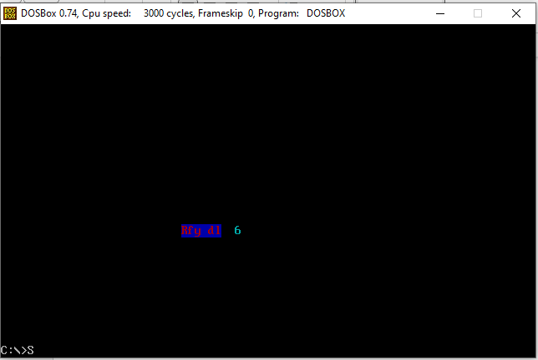
Best of luck

